**Firewall Configuration and Rule-based Filtering**

**Rule for Outbounds**

**Firewall Interface**

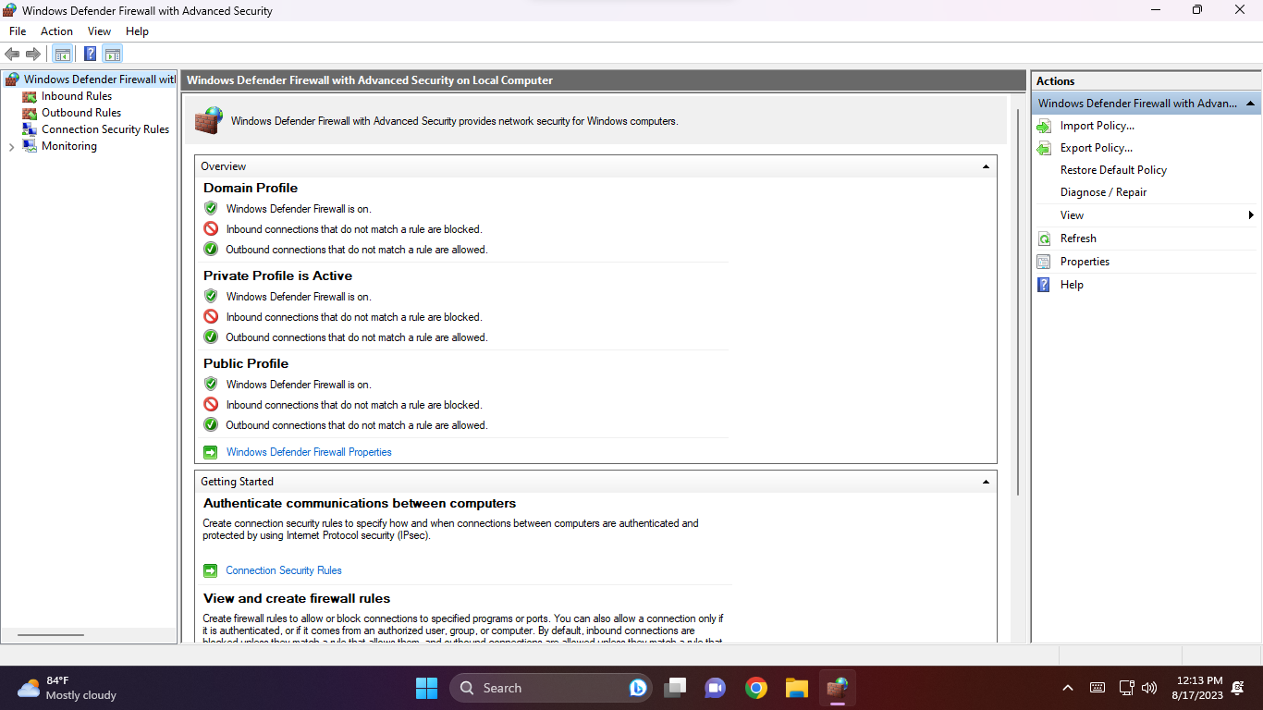

**Write a rule for Outbound**

**Select Outbound rules**

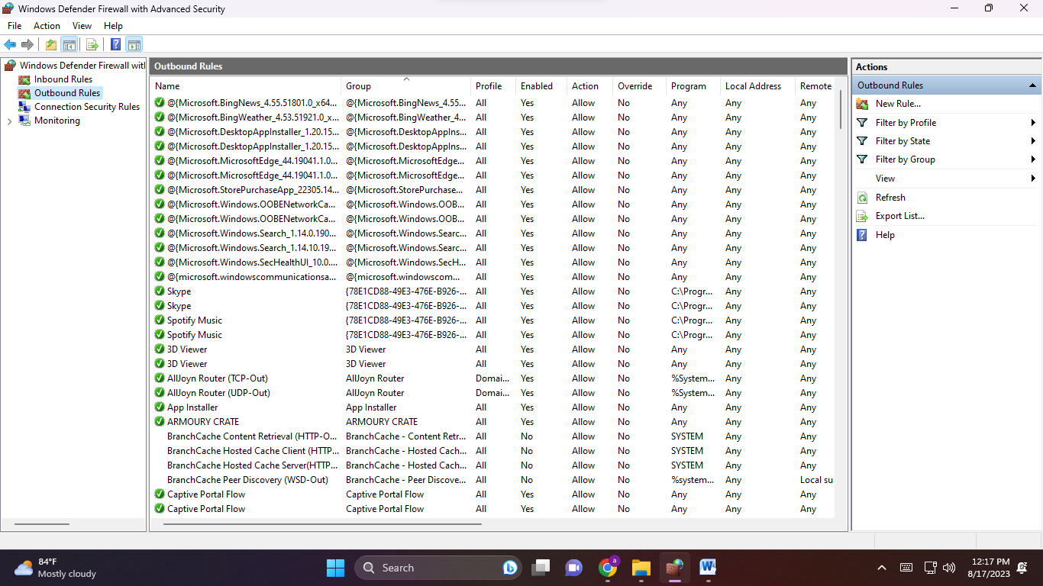

**Select the rule type:either rule for any Program /Port/Predefine/Custom**

**Here we are write rule for Port .**

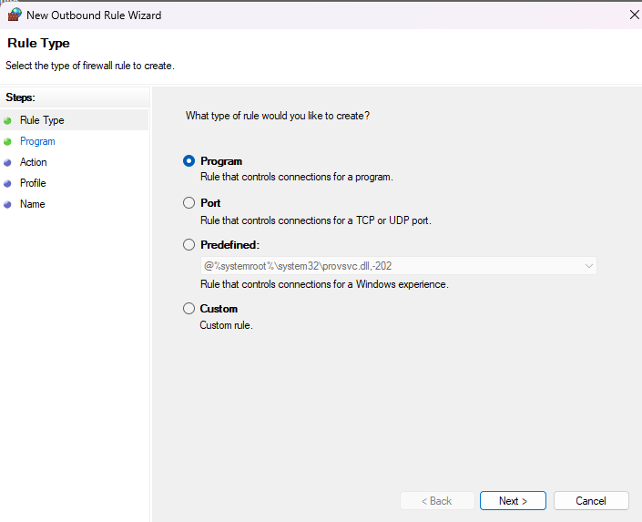

**After Selecting the port choose Either TCP or UDP . we are choosing TCP**

**Select TCP Protocol and Ports: Assign the for which port you want to apply the rule we are selecting 80 port**

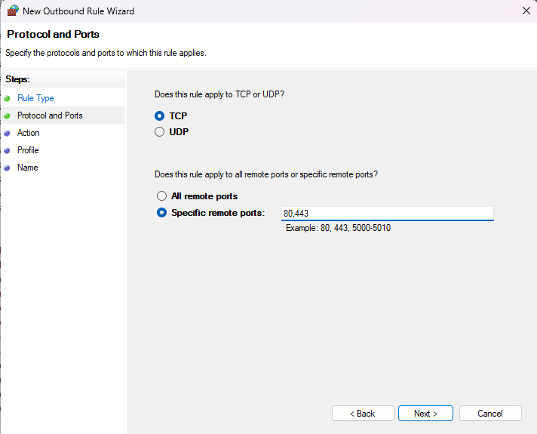

**Specify action for the rule: either you want to Allow the connection or block the connection. In this case we are block the connection**

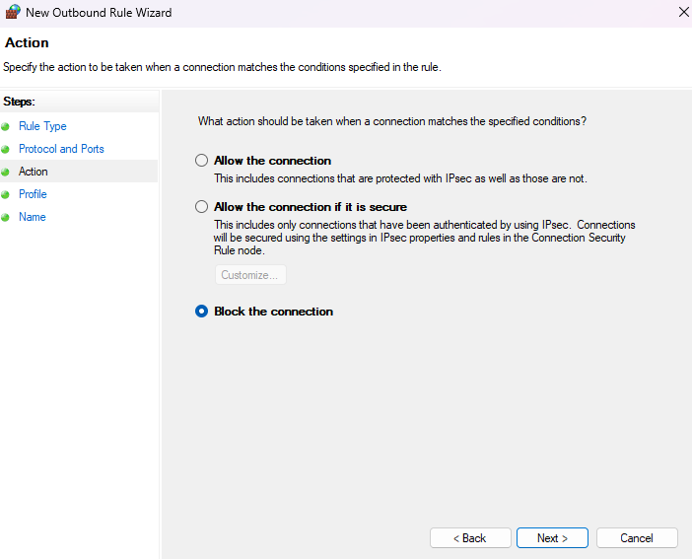

**Select the Profile to apply the rule:**

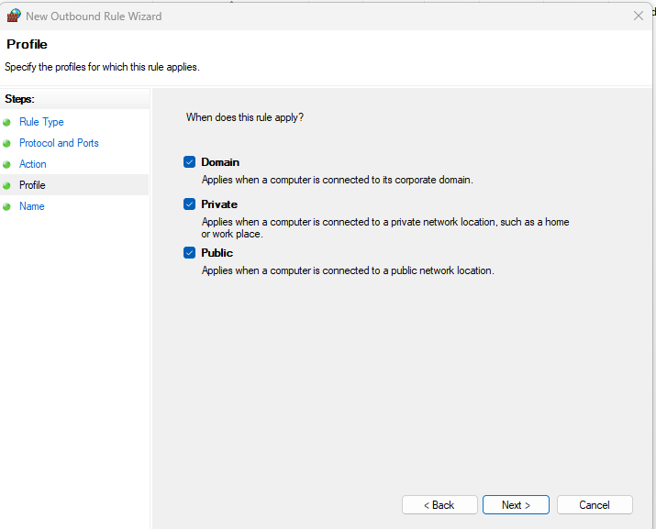

**Specify name for the rule:**

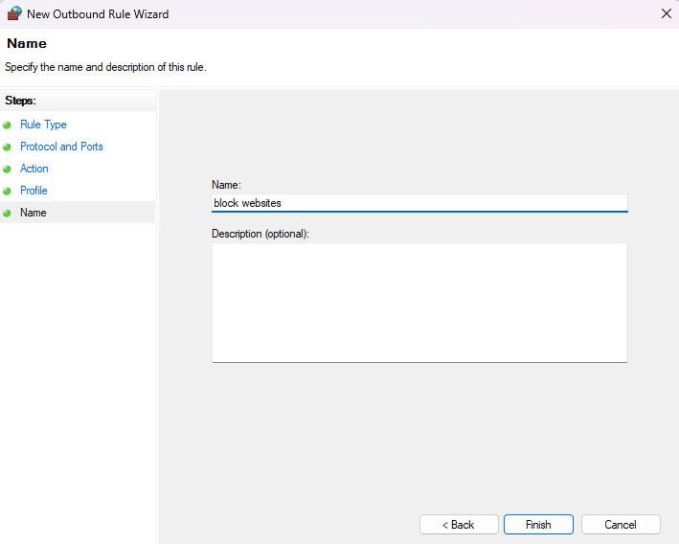

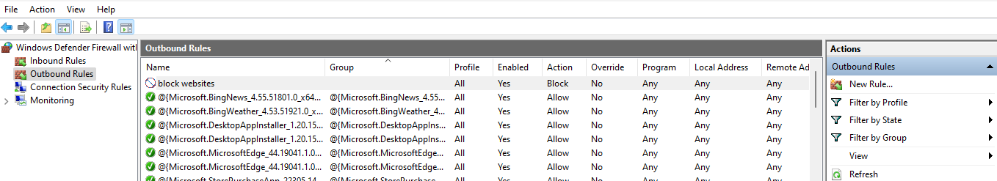

**Output:**

**After applying rule you want to open any website of port 80 it gives you following output**

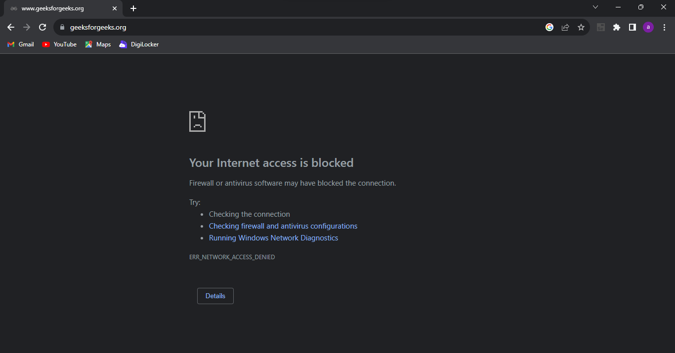

**Apply rule for public:**

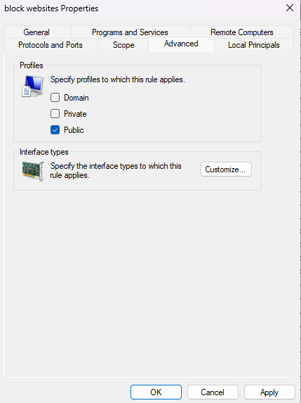

**Output:**

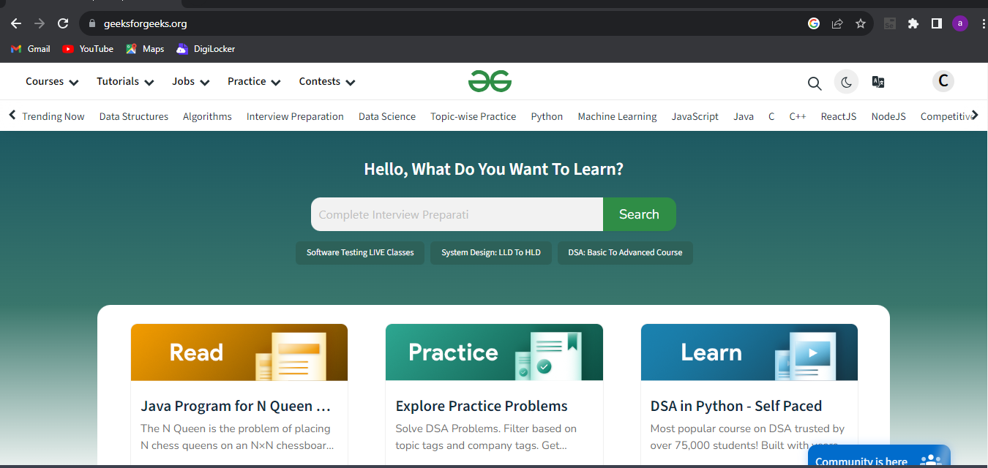

**Apply rule for Private:**

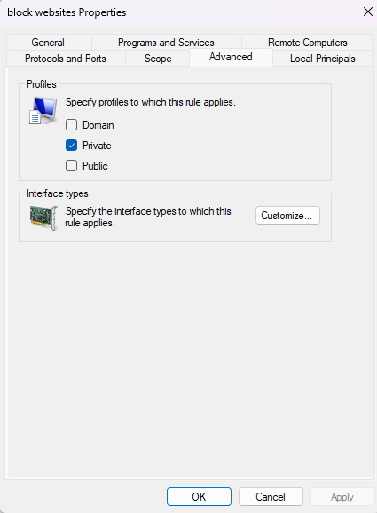

**Output:**

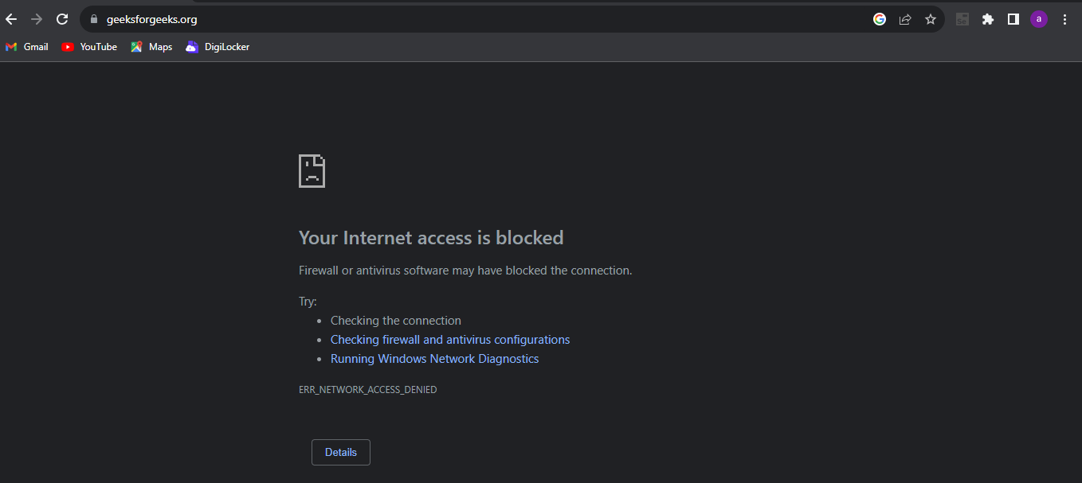

**After TCP we are Apply rule for UDP: Select UDP protocol and Ports:**

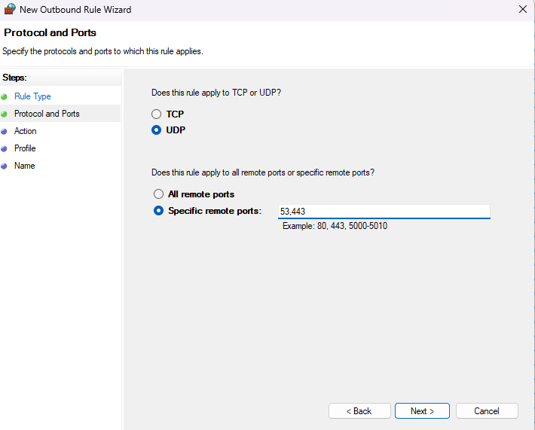

**Specify the action for the rule:**

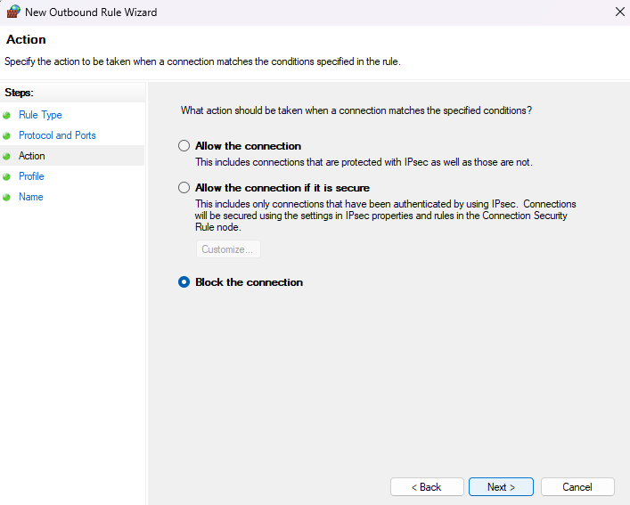

**Specify name for the rule:**

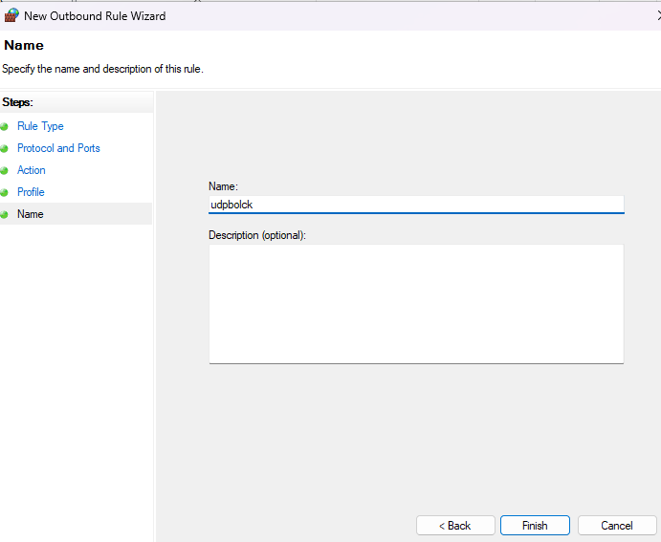

**Output:**

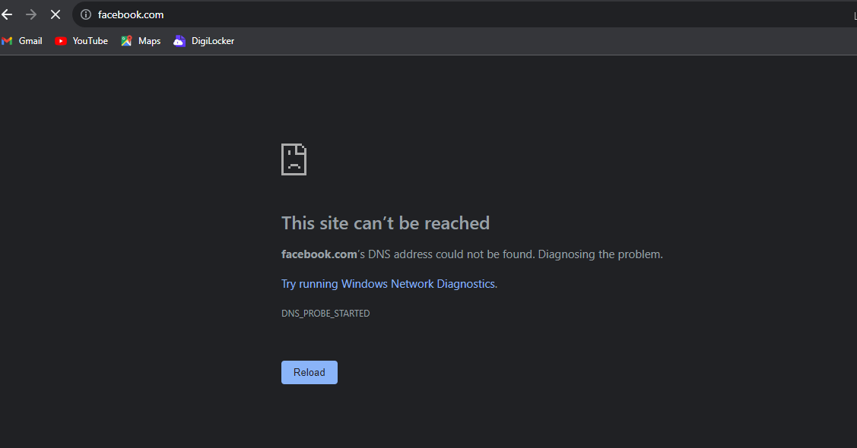

* **Write a rule for Inbound using Cisco packet tracer**

**Make a connection using 2 router (1941) , 2 switch, 3 PC**

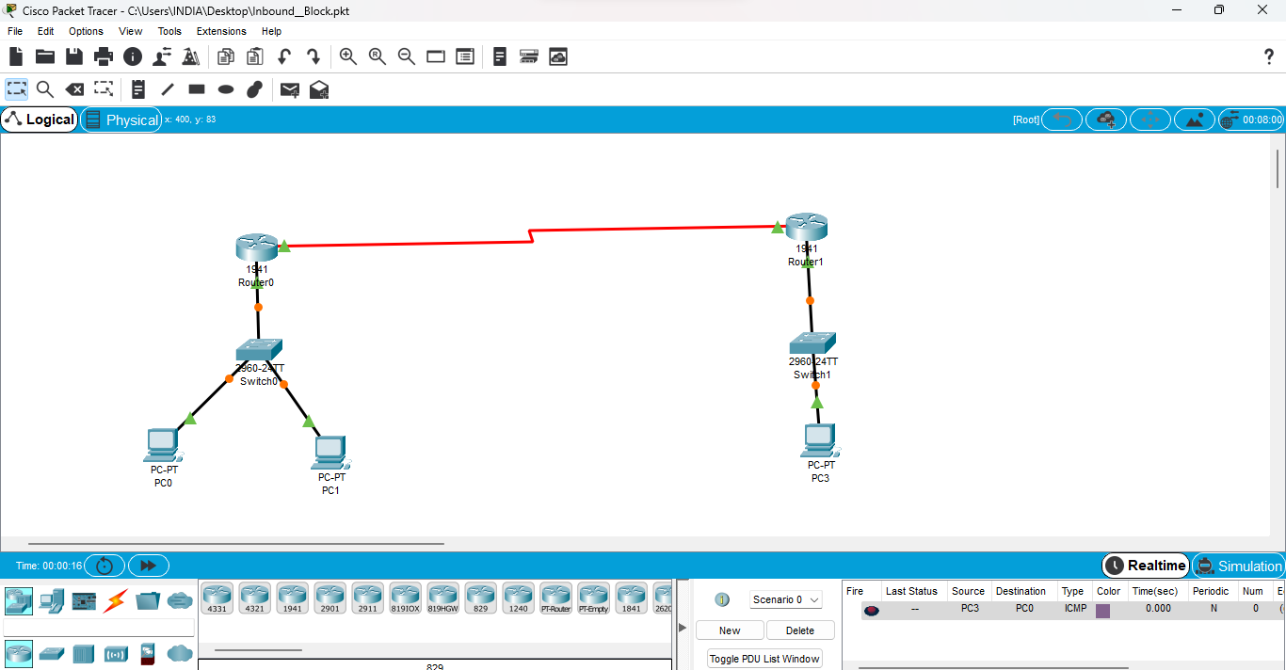

**Then assign the Ip address for the all pc and routers**

**Then give command to Router 1**

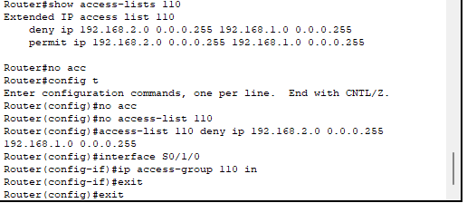

**After that send packet 192.168.2.0 to 192.168.1.0 it successfully reach at pc3 to pc0**

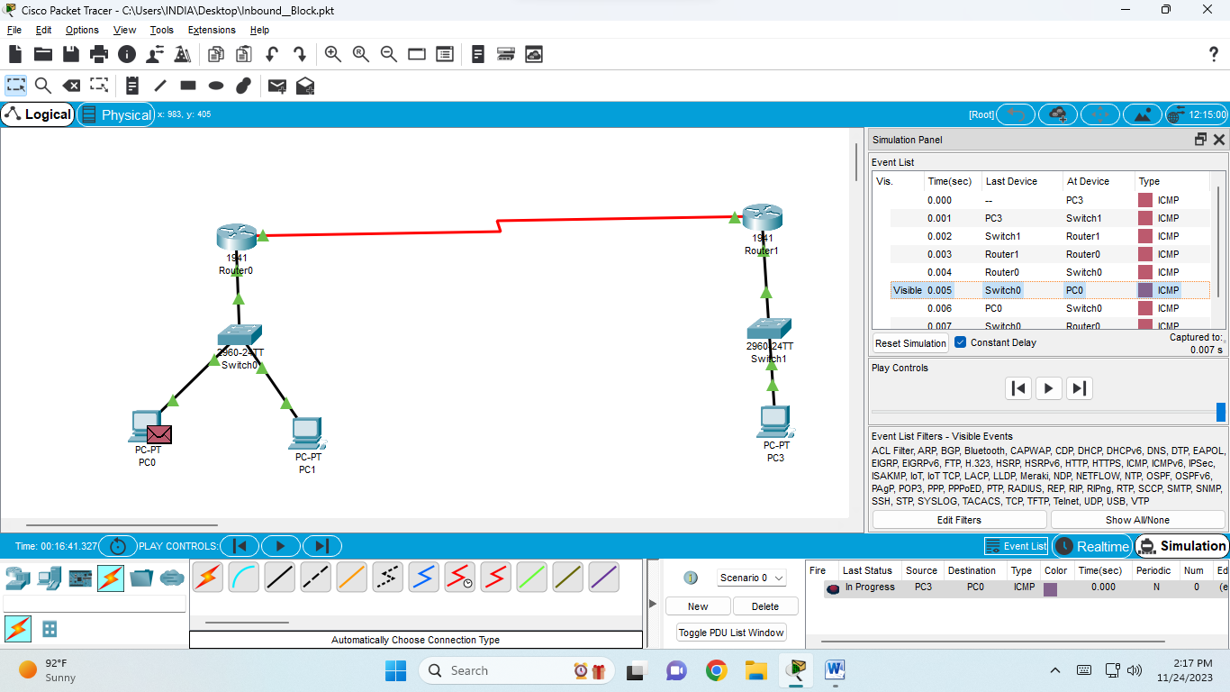

**But when it come back to the pc0 to pc3 it is failed at Router1 because we are write a rule for inbound**

